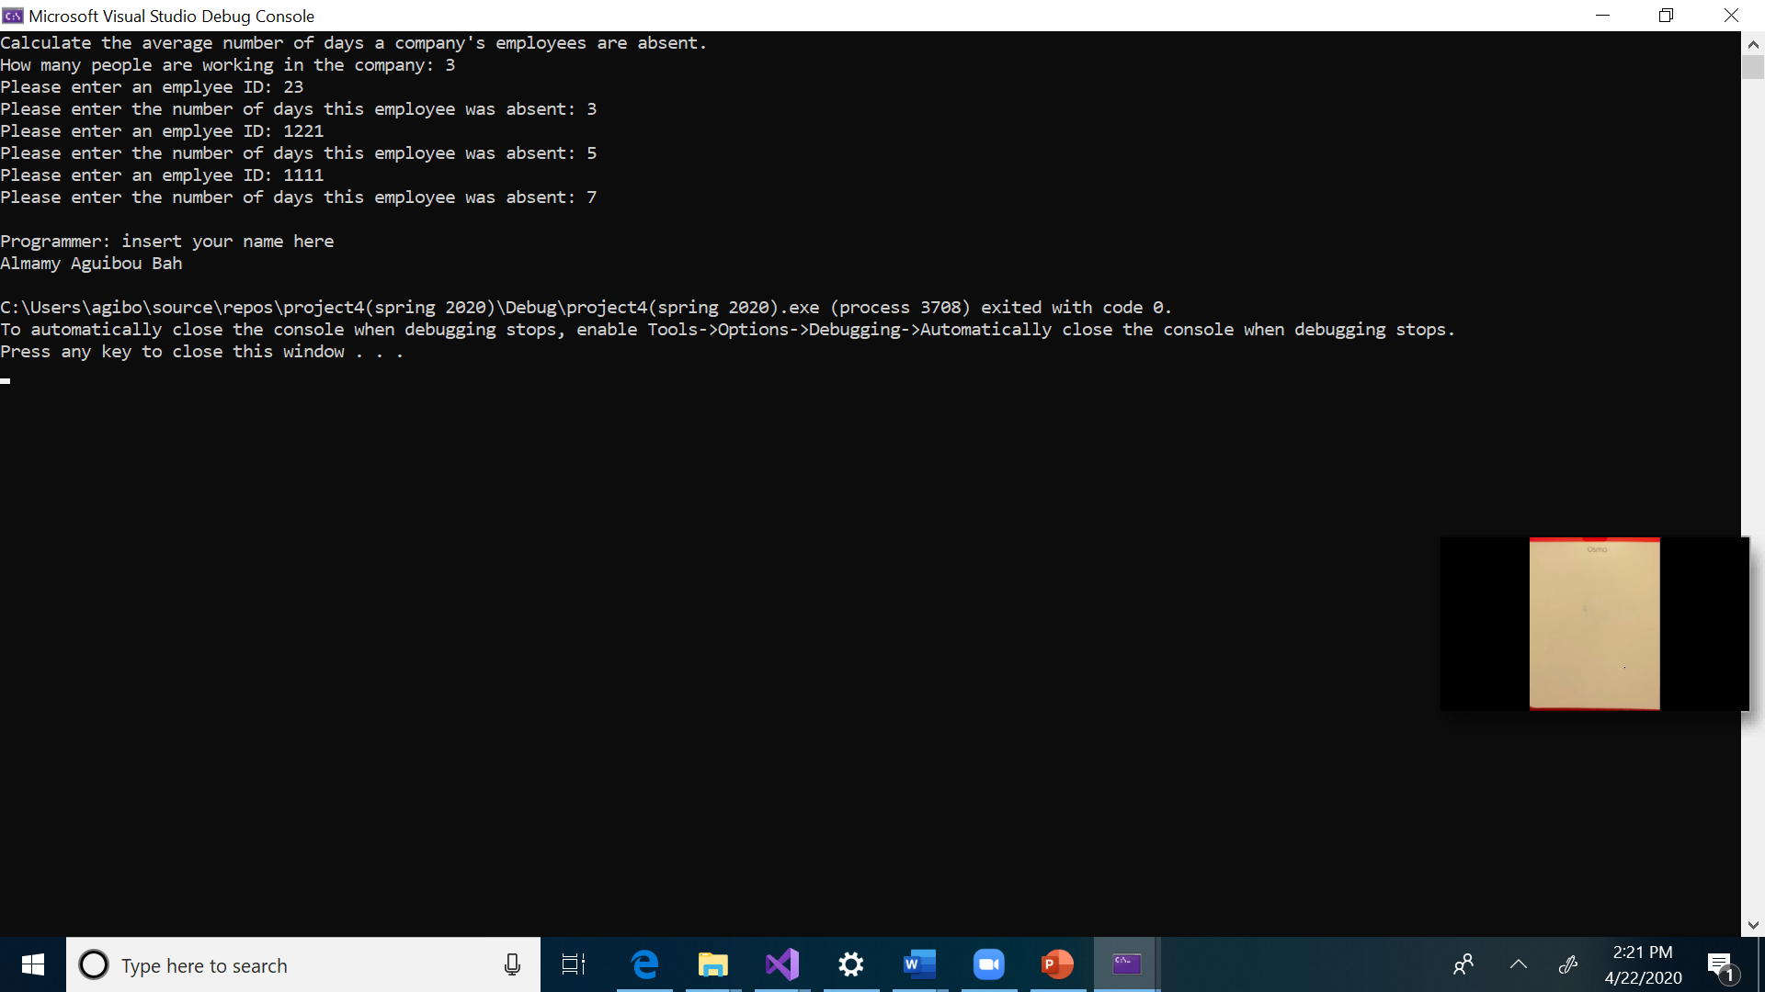

Test Plan:

|  |  |  |  |  |  |
| --- | --- | --- | --- | --- | --- |
| **Test Case #** | **Input** | **Actual Input** | **Expected Output** | **Actual Output** | **Did the test pass?** |
| 1 | No. of employees :  4  Employee ID’s/Days of absence : 1111 4  1112 5  1113 4  1114 3 |  | Total: 16  Average: 4.0 | Total: 16  Average: 4.0 | yes |
| 2 | No. of employees :  5  Employee ID’s/Days of absence : 1234 2  2234 4  3234 6  4234 9  234 4 |  | Total: 25  Average: 5.0 | Total: 25  Average: 5.0 | yes |
| 3 | No. of employees :  3  Employee ID’s/Days of absence : 12 3  4545 23  6544 2 |  | Total: 28  Average:9.33 | Total: 28  Average:9.33 | yes |
| 4 | No. of employees :  2  Employee ID’s/Days of absence : 122 3  4544 5 |  | Total: 8  Average:4.00 | Total: 8  Average:4.00 | yes |